Rollerball – 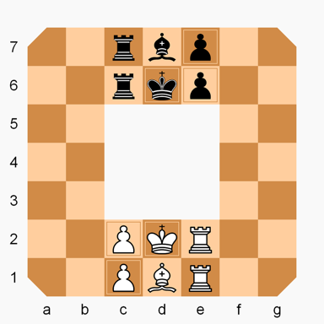Use Cases Document

Team Name: String Cheese

Team Members :

Chris Schaffer, Tim Stroup, Ya-Hsin Cheng, Sirius Chen, Meetkumar Savaliya

https://en.wikipedia.org/wiki/Rollerball_(chess_variant)

Use Cases Diagram:

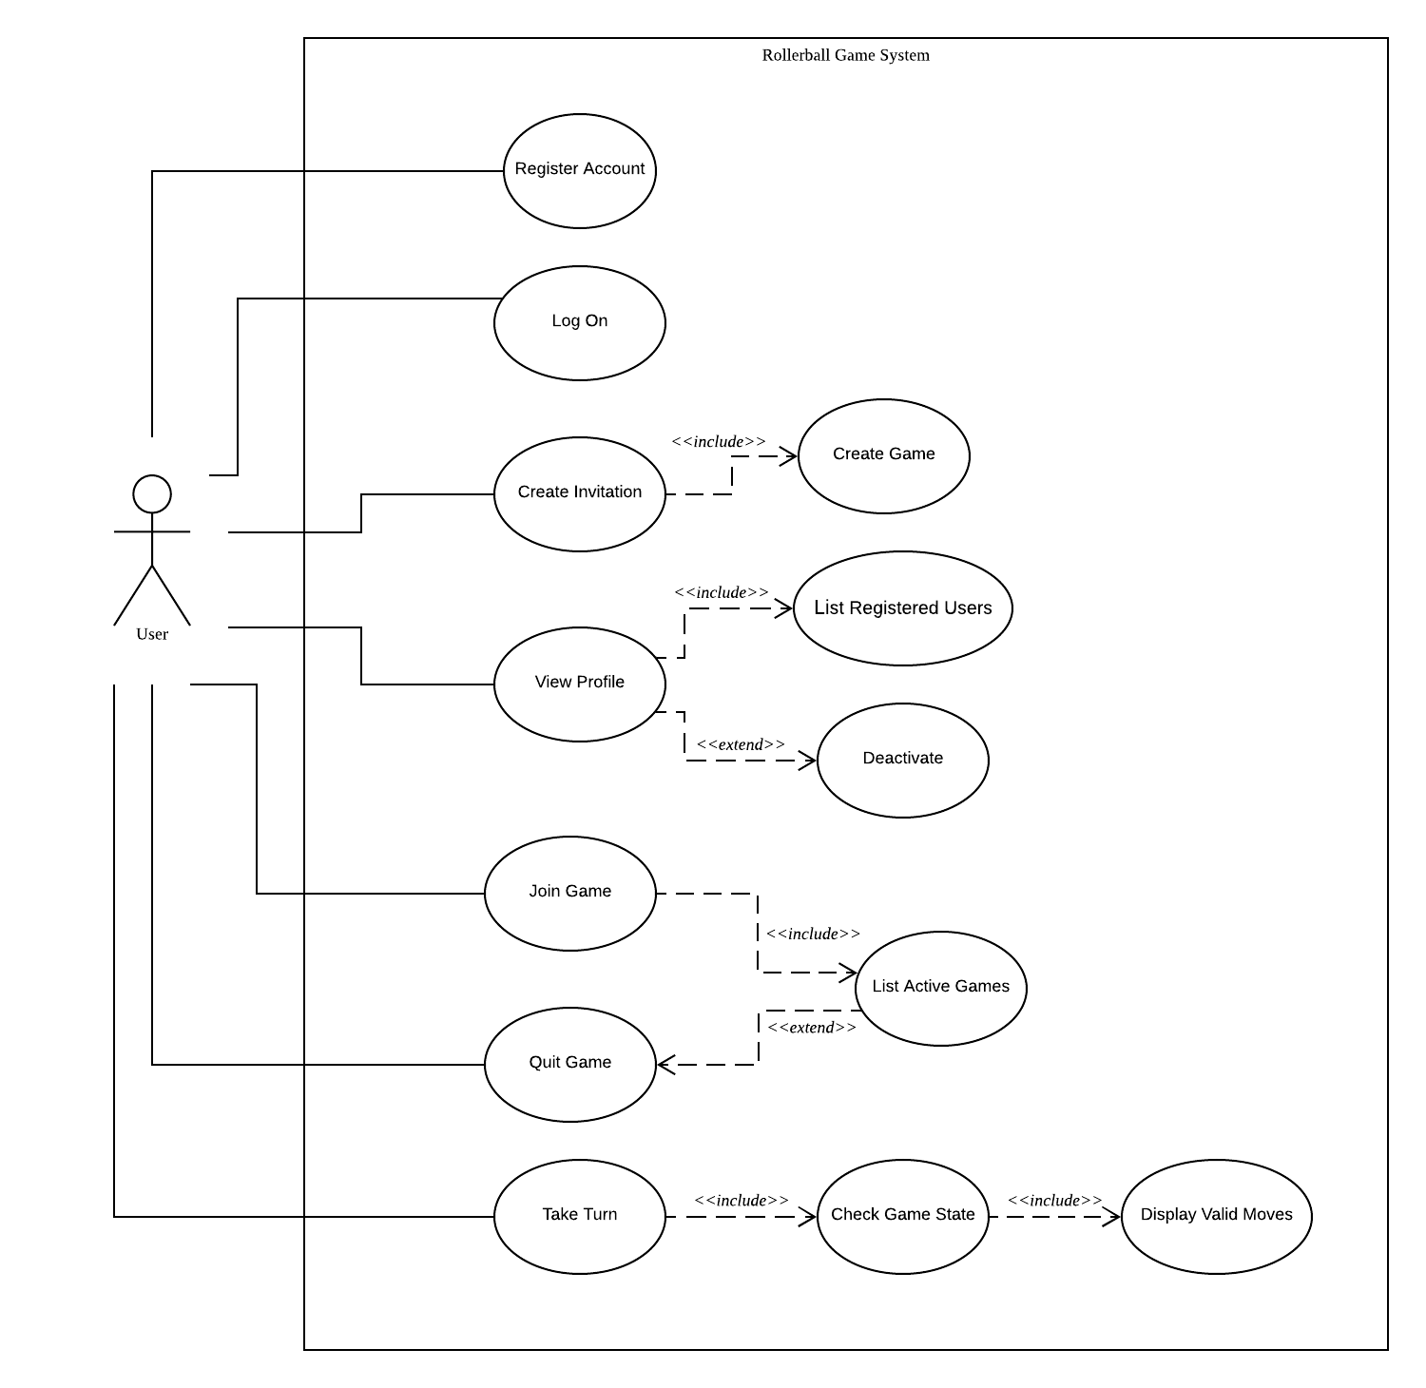

]

Use Case Descriptions:

|  |  |
| --- | --- |
| Use Case id: | 1 |
| Name | Register Account |
| Level | User goal |
| Primary Actor | User |
| Stakeholder  And Interest | User and System |
| Preconditions | User is connected to the system |
| Post conditions | User is registered with unique email and nickname |
| Main Success scenario | 1: User requests to register an account  2: User enters unique email address, nickname, and password  3: System Creates account  3: System reports that account was created  4: Use case ends |
| Extensions | 2A: Invalid email  1: System replies with the error in email(Already Registered, ill-formed)  2: Account is not Created  3: Return to step 1  2B: Invalid nickname  1: System replies that nickname is already registered  2: Account is not created  3: Return to step 1  2C: Network Error  1: Account is not created  2: Return to step 1 |

|  |  |
| --- | --- |
| Use Case id: | 2 |
| Name | Create Game |
| Scope | System |
| Level | User Goal |
| Primary Actor | User |
| Stakeholder  And Interest | User |
| Preconditions | User is registered and logged in to the system |
| Post conditions | Game is created |
| Main Success scenario | 1: User requests the system to create game  2: System creates game  3: System creates game id  4: System reports game creation was successful  5:Use case ends |
| Extensions | 1A: Network error  1: Game is not created  2: Use case ends |

|  |  |
| --- | --- |
| Use Case id: | 3 |
| Name | Create Invitation |
| Scope | System |
| Level | User Goal |
| Primary Actor | User |
| Stakeholder  And Interest | User |
| Preconditions | 1. User is registered and logged in 2. User has created a game |
| Post conditions | Invitations are sent |
| Main Success scenario | 1: User requests to create an invitation for a game  2: <<INCLUDE>> List Registered Users  3: User selects recipients of the invitation from the list  4: User requests to send the invitation  5: <<IINCLUDE>> create game  6: System sends invitation  7: Use case ends |
| Extensions | 1A: Invalid Game  1: System reports that you cannot create an invitation for this game  2: Use case Ends  1B: Network error  1: System reports it cannot create invitation  2: Use case ends  4A: Network error  1: System reports it cannot send an invitation  2: Use case ends |

|  |  |
| --- | --- |
| Use Case id: | 4 |
| Name | Deactivate account |
| Scope | System |
| Level | User goal |
| Primary Actor | User |
| Stakeholder  And Interest | User |
| Preconditions | User is registered and logged in |
| Post conditions | User account is deactivated |
| Main Success scenario | 1: User requests to deactivate their account  2: System request to confirm that user would like to deactivate account  3: System deactivates account and deletes user history  4: Use case ends |
| Extensions | 1A: Network error  1: Account is not deactivated  2: System reports account was not deactivated  3: Use case ends  2A: cancel deactivation  1: User responds no  2: User account is not deactivated  3: Use case ends |

|  |  |
| --- | --- |
| Use Case id: | 5 |
| Name | Join Game |
| Scope | System |
| Level | User Goal |
| Primary Actor | User |
| Stakeholder  And Interest | User |
| Preconditions | 1. User is registered and logged in.  2. User has received an invitation for a game with Game ID |
| Post conditions | User joins Game |
| Main Success scenario | 1: User requests join match screen  2: User enters game ID  3: User enters the game  4: Use case ends |
| Extensions | 2A: Game is full  1: System responds that game is full  2: User does not join game  3: Use case ends  2B: Game is no longer active  1: System responds that game is no longer active  2: User does not join game  3: Use case ends  2C: Network error  1: User is not entered into game  2: System reports it cannot connect to the game  3: Use case ends |

|  |  |
| --- | --- |
| Use Case id: | 6 |
| Name | View Profile |
| Scope | System |
| Level | User Goal |
| Primary Actor | User |
| Stakeholder  And Interest | User |
| Preconditions | 1. User is registered and logged in. |
| Post conditions | User profile is shown |
| Main Success scenario | 1: <<INCLUDE>> List Registered Users  2: User selects user from list  2: User requests to view profile  3: System displays profile information  4: Use case ends |
| Extensions | 2A: Network error  1: System does not display profile information  2: System reports it cannot display profile  3: Use case ends |

|  |  |
| --- | --- |
| Use Case id: | 7 |
| Name | Log on |
| Scope | System |
| Level | subfunction |
| Primary Actor | User |
| Stakeholder  And Interest | User |
| Preconditions | User is Registered. |
| Post conditions | User is logged in |
| Main Success scenario | 1: User enters nickname and password  2: User requests to log on to the system  3: User is logged in  4: Use case ends |
| Extensions | 2A: invalid password or nickname  1:User is not logged in  2: System reports password or nickname does not match a valid pair  3: Use case ends  2B: Network error  1: User is not logged in  2: System reports it cannot connect  3: Use case ends |

|  |  |
| --- | --- |
| Use Case id: | 8 |
| Name | Quit game |
| Scope | System |
| Level | User Goal |
| Primary Actor | User |
| Stakeholder  And Interest | User |
| Preconditions | 1. User is registered and logged in.  2. User has created or joined a game. |
| Post conditions | User has quit the game |
| Main Success scenario | 1: <<INCLUDE>> List active games  2: User selects and active game from the list  3: User requests to quit the game.  4: User quits the game  5: <<INCLUDE>>Save completed game  6: System reports game was successfully quit  7: Use case ends |
| Extensions | 3A: Network error  1: User does not quit game  2: System reports it cannot connect and game was not quit  3: Use case ends |

|  |  |
| --- | --- |
| Use Case id: | 9 |
| Name | List active games |
| Scope | System |
| Level | User Goal |
| Primary Actor | User |
| Stakeholder  And Interest | User |
| Preconditions | User is registered and logged in. |
| Post conditions | User’s Active Games are listed |
| Main Success scenario | 1: User requests to list their active games  2: Active games are listed  3: Use case ends |
| Extensions | 1A: Network error  1: Active games are not lister  2: System reports it cannot connect  3: Use case ends  2a: No active games  1: System responds that there are no active games  2: Use case ends |

|  |  |
| --- | --- |
| Use Case id: | 10 |
| Name | Take Turn |
| Scope | System |
| Level | User goal |
| Primary Actor | User |
| Stakeholder  And Interest | User |
| Preconditions | 1. User is logged in and registered  2. It is the User’s turn |
| Post conditions | User has moved a piece and turn is over |
| Main Success scenario | 1: <<INCLUDE>> List Active Games  2: User selects a game  3: User selects piece to move  4: <<INCLUDE>> Get valid moves  5: User selects move from valid moves  6: piece is moved  7: <<INCLUDE>> Update game state  8: Use case ends |
| Extensions | 3A: Invalid piece  1: System reports user can not move this piece  2: return to main flow step 3  4A: No valid moves  1: The System reports no valid moves  2: return to main flow step 3  5A: Game is invalid  1: System reports that game is no longer valid  2: Use case ends  7A: Game is over  1: <<INCLUDE>> Save completed game  2: System reports game is completed  3: Use case ends |

|  |  |
| --- | --- |
| Use Case id: | 11 |
| Name | Update Game State |
| Scope | System |
| Level | subfunction |
| Primary Actor | System |
| Stakeholder  And Interest | System |
| Preconditions | 1. User is logged in and registered  2. User has moved a piece |
| Post conditions | Game state has been updated |
| Main Success scenario | 1: System saves the new state  2: The system checks whether the game is over  3: Use case ends |
| Extensions | 2A: The game is over  1: <<INCLUDE>> Save completed game  2: The system reports that the game is over  3: Use case ends |

|  |  |
| --- | --- |
| Use Case id: | 12 |
| Name | Display Valid Moves |
| Scope | System |
| Level | subfunction |
| Primary Actor | System |
| Stakeholder  And Interest | System |
| Preconditions | 1. User is logged in and registered  2. User taking a turn  3. User has selected a valid piece |
| Post conditions | Valid moves are returned |
| Main Success scenario | 1: The system checks for valid moves for a piece and board state  2: The system returns the valid moves for a piece and board state  3: Use case ends |
| Extensions | 1A: No valid moves  1: The system reports there are no valid moves  2: Use case ends |

|  |  |
| --- | --- |
| Use Case id: | 13 |
| Name | Save Completed game |
| Scope | System |
| Level | subfunction |
| Primary Actor | System |
| Stakeholder  And Interest | System |
| Preconditions | 1. User is logged in and registered  2. The game is over |
| Post conditions | Finished game is saved in player history |
| Main Success scenario | 1: The system saves the finished game in each players’ history  2: The system records the winner of the game  3: Use case ends |
| Extensions | 2A: The game was a tie  1: The system records the game as a tie  2: Use case ends |